My Corona Virus Story

Look outside your window and draw what you see.

Once upon a time I used to like to go to the ______________________ and ________________________.

Draw a picture of your favorite places to go.
On very special days I would go to ____________________________ and __________________________.

Draw a picture of special places to go.
I used to play with ____________________ and __________________.

Draw a picture of someone you used to play with.
I used to visit with _____________________ and _________________.

Draw a picture of someone you used to visit.
Then this thing called the Corona Virus came to my town. It is very, very small and we can’t even see it. If I drew a very big picture of it, it would look something like this.
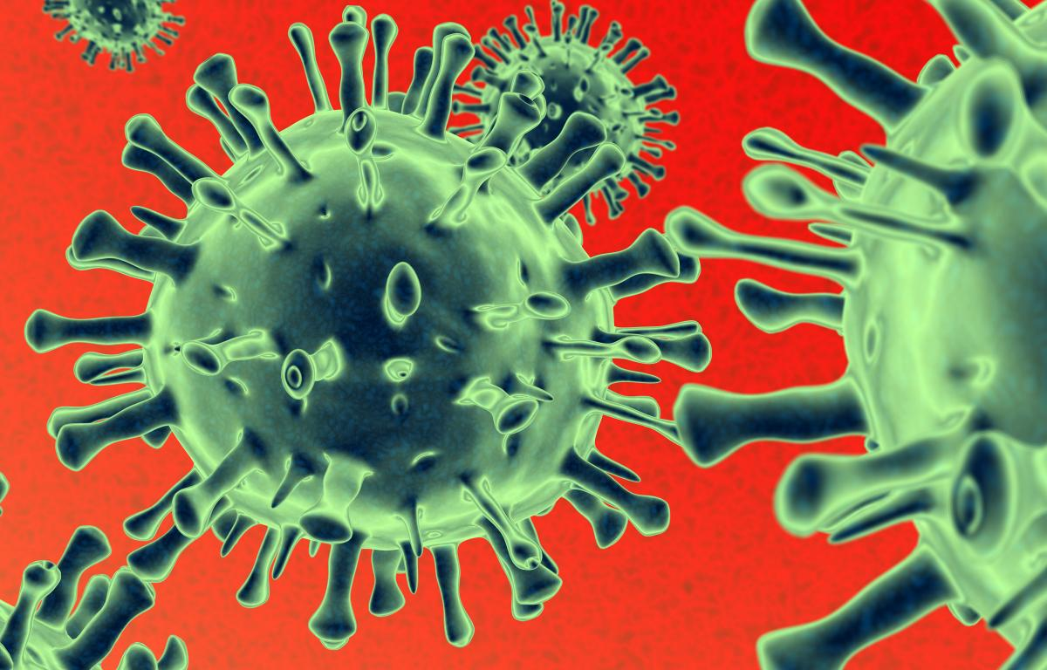
If someone catches this virus, they might get very sick.
Now I do things to stay safer.
SOCIAL DISTANCING
I need to stay two arms lengths away from anyone who doesn’t live with me.
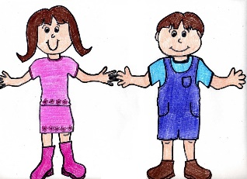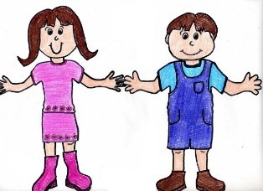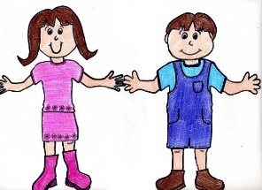
WASH MY HANDS
I wash my hands with soap and water while singing the ABC Song all the way to the end. Washing with soap and water, protects from the virus. 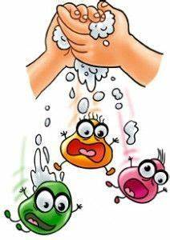
DON’T TOUCH!
I keep my hands away from my nose, eyes and mouth.

Draw eyes, nose, and mouth.

STAY HOME
I stay home and follow directions from my ___________________.

Draw a picture of my room.
COVER THE COUGH AND SNEEZE
I cough and sneeze into my arm.
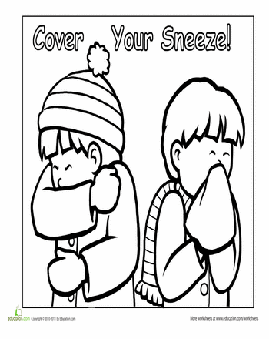

SPECIAL PEOPLE KEEP ME SAFE

My _________________ and __________________ keep me safe.

ONE DAY SOON
One day soon things will get better. The virus will be controlled. It will be good to go out again. Then, I will go back to the __________________________ and __________________________. On special days I will go to ___________________________ and ______________________________.
I will play with _______________________ and ___________________________.
Until then, my _____________________, _____________________ and the ________________________________ and ____________________________ keep me safe.

Draw a picture of that happy day.

