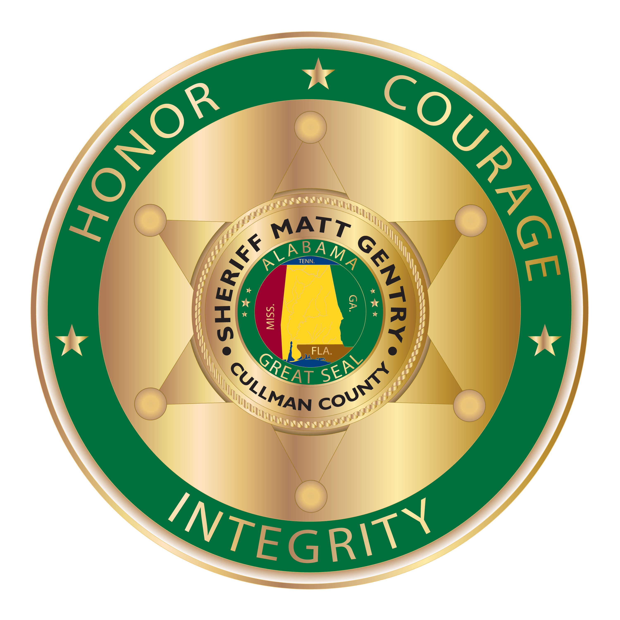

For Immediate Release

TO: All Local Media

From: Sheriff Matt Gentry

Two Arrested in Connection to Multi-State Crime Ring related to Fraud and Theft

Tuesday, February 04, 2020, Cullman County Sheriff’s Office (CCSO) Investigators, arrested John David Boggs, 45 years old of Louisville, KY and Amanda Christine Lairsey, 32 years old of Spring Hill, TN for five counts of Theft of Property 1st, respectively.

Recently, CCSO Investigators received multiple cases involving My Affordable Roofing defrauding victims of their money. My Affordable Roofing is headquartered in Louisville, Kentucky and is owned by John David Boggs and Amanda Christine Lairsey.

Mr. Boggs and Ms. Lairsey opened a location in Cullman, AL in the spring of 2018 after the extensive hail storm damaged many homes and businesses in Cullman on March 18, 2018. CCSO Investigators began receiving multiple reports about My Affordable Roofing taking victims money and not showing back up and ignoring phone calls from their clients.

CCSO Investigators began a lengthy investigation and found that My Affordable Roofing did complete a few jobs in the very beginning of 2018, right after the hail storm, but began to sale other jobs and not complete the work. As of today, January 16th 2020, CCSO has taken six reports from victims and the total loss to victims, just in Cullman, AL, is $167,045. Estimates are there could be up to 30 total victims in the Cullman County area that have still not filed a report with the CCSO.

Continuing the investigation, CCSO investigators were contacted by a civil attorney that made CCSO aware of a pattern with My Affordable Roofing owners John David Boggs and Amanda Lairsey. Investigators were able to discover the pattern of the same type of deceptive practices extending across multiple states that ranged from Indiana to Florida. Investigators were also able to uncover that Mr. Boggs was deeply in debt after multiple recent purchases in the state of Florida of luxury homes, a large fishing yacht and leasing private aircraft from money earned from his victims in Cullman, as well as other states. Consulting with the civil attorney, as well as through the investigation, investigators estimate the losses to victims in all the states combined could be well over one million dollars.

“This is a major case and we are still encouraging anyone that could be a victim of My Affordable Roofing to come forward. It appears through our investigation these suspects blatantly deceived customers and took their money with no intention of doing the work”, said Sheriff Matt Gentry. “I would like to commend the investigators who worked long hours on this case and who are continuing to work on this case so the victims can hopefully recover their money,” added Gentry.

Other charges maybe pending as the investigation continues.

Both suspects have made bond.

If someone believes they may be a victim of My Affordable Roofing please contact Investigator Trevor Clemmons.

-30-

